**Write a blog on Difference between HTTP1.1 vs HTTP2**

**HTTP/2: the difference between HTTP/1.1**

# HTTP:

**Hypertext Transfer Protocol (HTTP)** is an application protocol that is, currently, **the foundation** of data communication for the World Wide Web.

**HTTP is based on** the Client/Server model. Client/Server model can be explained as two computers, Client (receiver of service) and Server (provider of service) that are communicating via requests and responses.

**HTTP/2:**

In 2015, Internet Engineering Task Force (IETF) release HTTP/2, the second major version of the most useful internet protocol, HTTP. It was derived from the earlier experimental SPDY protocol.

**Main goals of developing HTTP/2 was:**

* Protocol negotiation mechanism — protocol electing, eg. HTTP/1.1, HTTP/2 or other.
* High-level compatibility with HTTP/1.1 — methods, status codes, URIs and header fields.
* Page load speed improvements trough:
* Compression of request headers
* Binary protocol
* HTTP/2 Server Push
* Request multiplexing over a single TCP connection
* Request pipelining
* HOL blocking (Head-of-line) — Package blocking

### HTTP/1.1

Developed by Timothy Berners-Lee in 1989 as a communication standard for the World Wide Web, HTTP is a top-level application protocol that exchanges information between a client computer and a local or remote web server. In this process, a client sends a text-based request to a server by calling a method like **GET or POST**. In response, the server sends a resource like an HTML page back to the client.

### HTTP/2

HTTP/2 began as the SPDY protocol, developed primarily at Google with the intention of reducing web page load latency by using techniques such as compression, multiplexing, and prioritization. This protocol served as a template for HTTP/2 when the Hypertext Transfer Protocol working group httpbis of the [IETF (Internet Engineering Task Force)](https://www.ietf.org/) put the standard together, culminating in the publication of HTTP/2 in May 2015. From the beginning, many browsers supported this standardization effort, including Chrome, Opera, Internet Explorer, and Safari. Due in part to this browser support, there has been a significant adoption rate of the protocol since 2015, with especially high rates among new sites.

**HTTP/2 Server Push**

This capability allows the server to send additional cacheable information to the client that isn’t requested but is anticipated in future requests. For example, if the client requests for the resource X and it is understood that the resource Y is referenced with the requested file, the server can choose to push Y along with X instead of waiting for an appropriate client request.

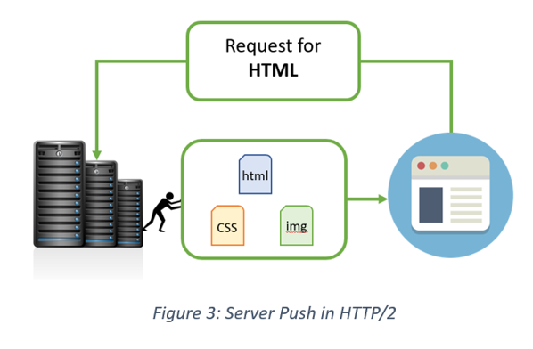

**Benefits:**

* The client saves pushed resources in the cache.
* The client can reuse these cached resources across different pages.
* The server can multiplex pushed resources along with originally requested information within the same TCP connection.
* The server can prioritize pushed resources — a key performance differentiator in HTTP/2 vs HTTP1.
* The client can decline pushed resources to maintain an effective repository of cached resources or disable Server Push entirely.
* The client can also limit the number of pushed streams multiplexed concurrently.
* The real difference between HTTP/1.1 and HTTP/2 comes with server push example.
* Imagine that the guest (Client) asks (sends request) waiter (Server) for a meal, then the waiter gets the meal from the restaurant chef (your application logic), but the waiter also thinks you would need a bottle of water so he brings that too with your meal. The end result of this would be only one TCP connection and only one request that will significantly lower the server load.